How to use Commix
- Run Commix.exe. And then set the communication parameters (Type, IP Address, Port, Baud Rate, Data Bits, Parity, Stop Bits).
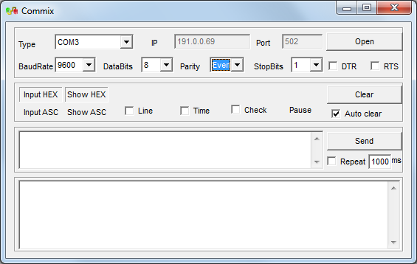
- Click “Open”.
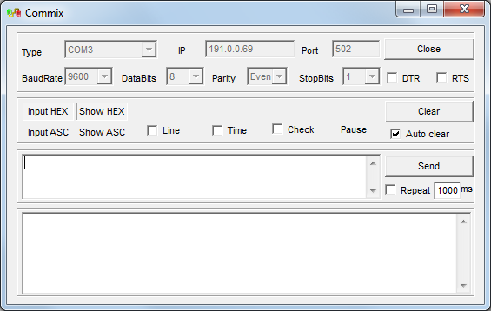
- Enter the Modbus command in the blank window. For example, to read the kWh Import registers of the PMC-330, which ID=112, start address=0100, enter 70 03 00 64 00 02 in HEX.
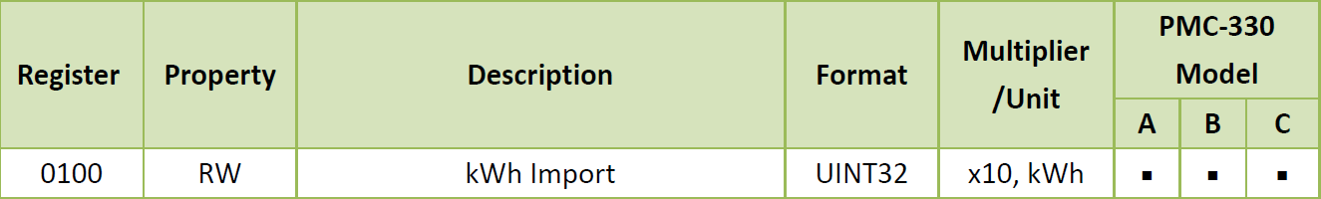
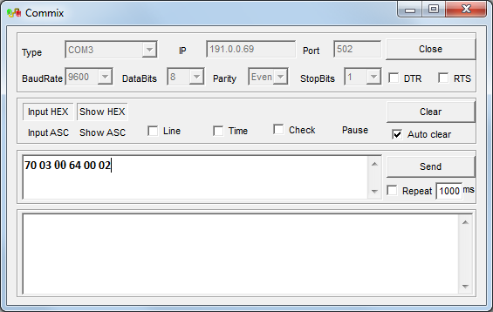

- Select the “Check” checkbox and click “OK”.
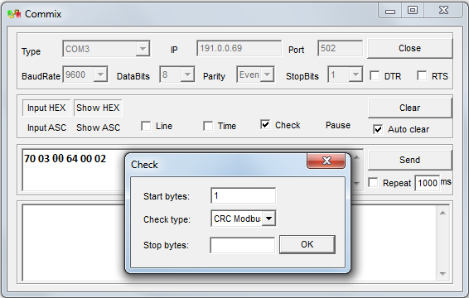

- Click “Send”.
If the meter is connected, the Read Holding Registers Request Packet and Response Packet are shown in the window.
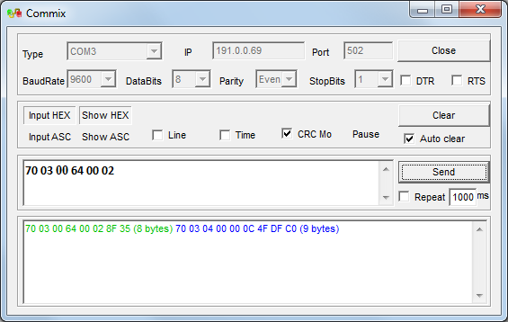
If the meter is not able to communicate, the Read Holding Registers Request Packet is shown in the window, but no Response Packet will be displayed.
